STAMFORDHAM CLASSIC & SPORTS CAR SHOW 2021
Thank you for registering for the 2021 SCSCS – 12-4pm on Monday 30th August.
This year it is taking place at STAMFORDHAM CRICKET CLUB – the nearest postcode is NE18 0QT.
Please provide the following details:
Name: | Contact Number: | Vehicle details:
If the weather is inclement, the event will be postponed until Sunday 5th September – the number you provide will be used to alert you to this fact.
This is a small, informal show with no entry fee, and no prizes/awards. It is held annually – and this year is going to be at Stamfordham Cricket Club on the outskirts of the village (not on the village green).
We expect around 100 vehicles on show, ranging from vintage cars and classics, to more modern sports cars.
There will be a pizza van, ice cream van, and a bar open at the cricket club pavilion.
COVID-19 MEASURES WILL BE IN PLACE - AS NECESSARY. DO NOT ATTEND IF YOU HAVE C-19 SYMPTOMS
Please arrive no later than 11am to ensure you are in position before the crowds arrive and remain in situ until at least 4 o’clock. Thank you – we look forward to seeing you and your vehicle at the 2021 Stamfordham Classic and Sports Car Show!
Show Contact: James Freeman-Griffith, 07813 949007.
www.Facebook.com/stamcarshow
SMALL PRINT:
The information you provide will not be shared or stored/retained beyond the date of the event.
You must ensure that your vehicle is roadworthy (if being driven to the event) and insured appropriately.
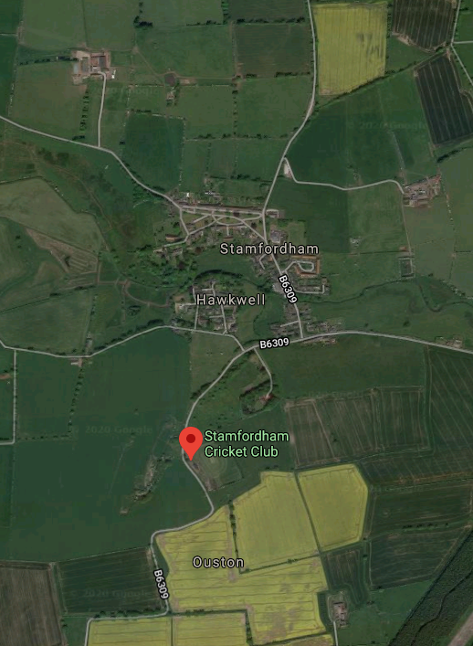
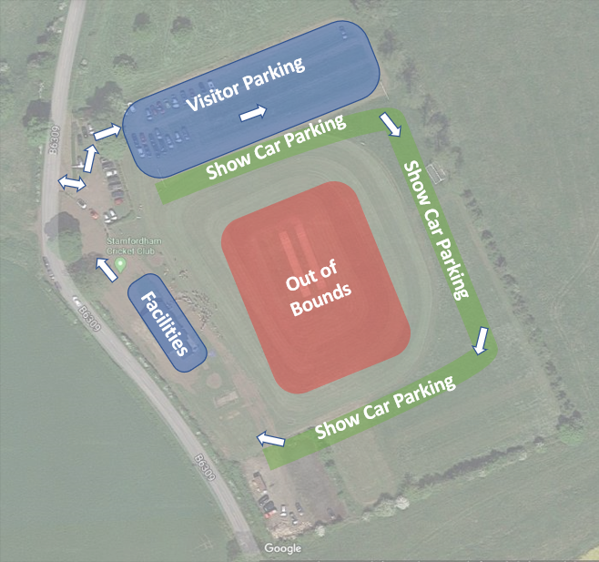
The organisers do not accept liability for any injury or damage arising as a result of entry into the event.

