TECHNICAL TIPS – CHANGING A DRIBBLE INTO A SPURT

Despite the title, this is not an article that might be of interest to men of advancing years!

Once again I was at a loss knowing what to put on my Christmas present list, having nearly exhausted all the goodies I could get for my MGB.

I finally decided on an electric windscreen washer kit to replace the rather feeble manual push button system that was already fitted.

According to MG websites some people have taken apart the manual pump and inserted a microswitch inside it to operate a new electric pump. This sounds a bit complicated, and not being a stickler for originality I thought I would just use a Lucas style push button switch in the hole in the dashboard where the manual pump was located. That way I could keep the manual pump intact in case anyone wanted to return the car to its original configuration in future.
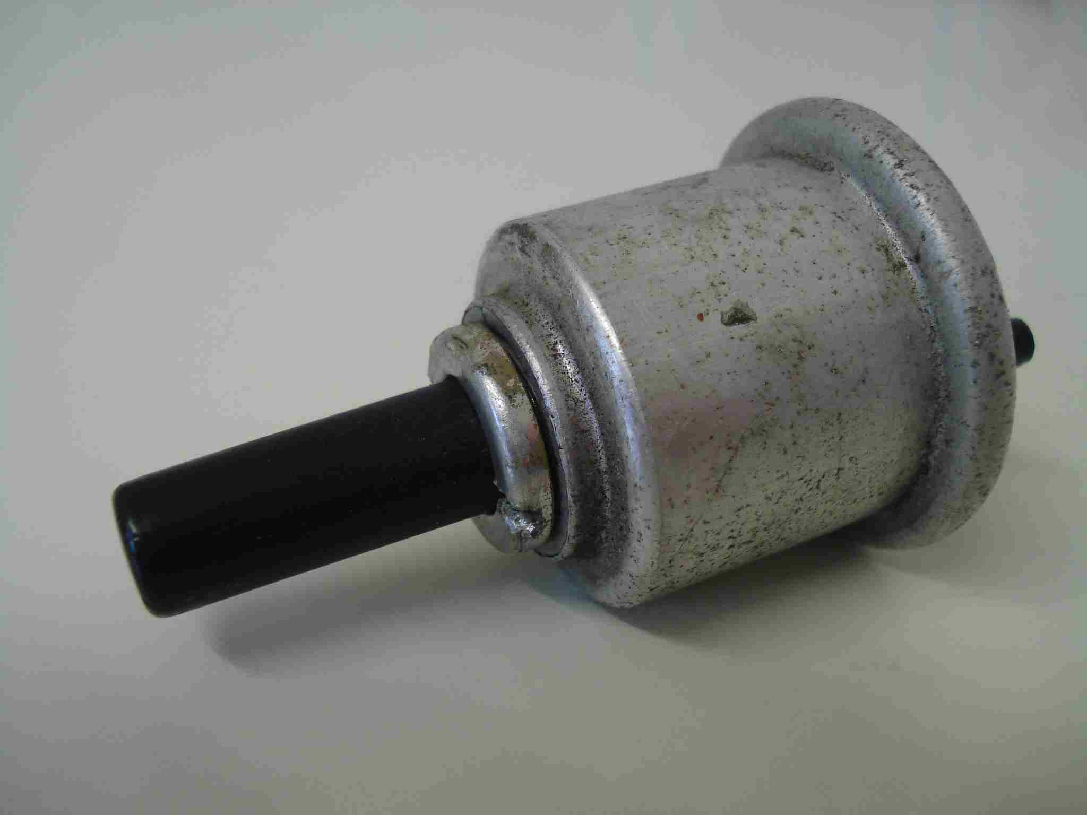
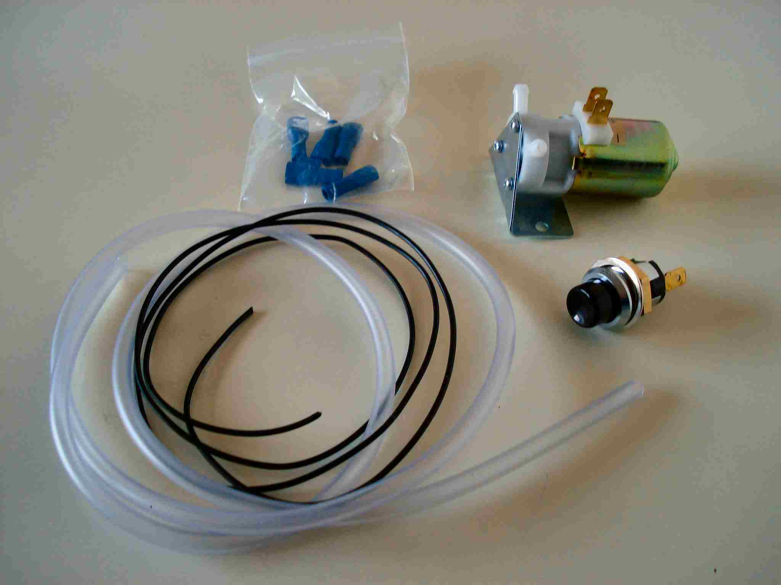

Original manual pump New electric pump kit

I bought the kit (or rather Santa did) from the MG Owners Club and it came with everything apart from instructions. However, the installation is very simple:

- Connect one terminal on the new switch to a 12volt supply that is live when the ignition is on.
- Connect the other terminal on the new switch to the positive terminal on the new pump.
- Connect the negative terminal on the new pump to a convenient earth point.
- Connect the plastic hose from the washer bottle to the inlet on the pump.
- Connect the plastic hose from the washer jets to the outlet on the pump.

I found that I had to enlarge the hole in the dashboard to take the new Lucas style switch, and I had to use some of the new plastic tubing to extend the length of the tubing from the tee piece leading to the jets.

I mounted the new pump inside the car on the bulkhead under the dashboard to the left of the centre console using self-adhesive pads. Fortunately when I turned the pump on for the first time it primed itself, and I had connected the inlet and outlet tubes on the correct nipples so water flowed in the right direction.

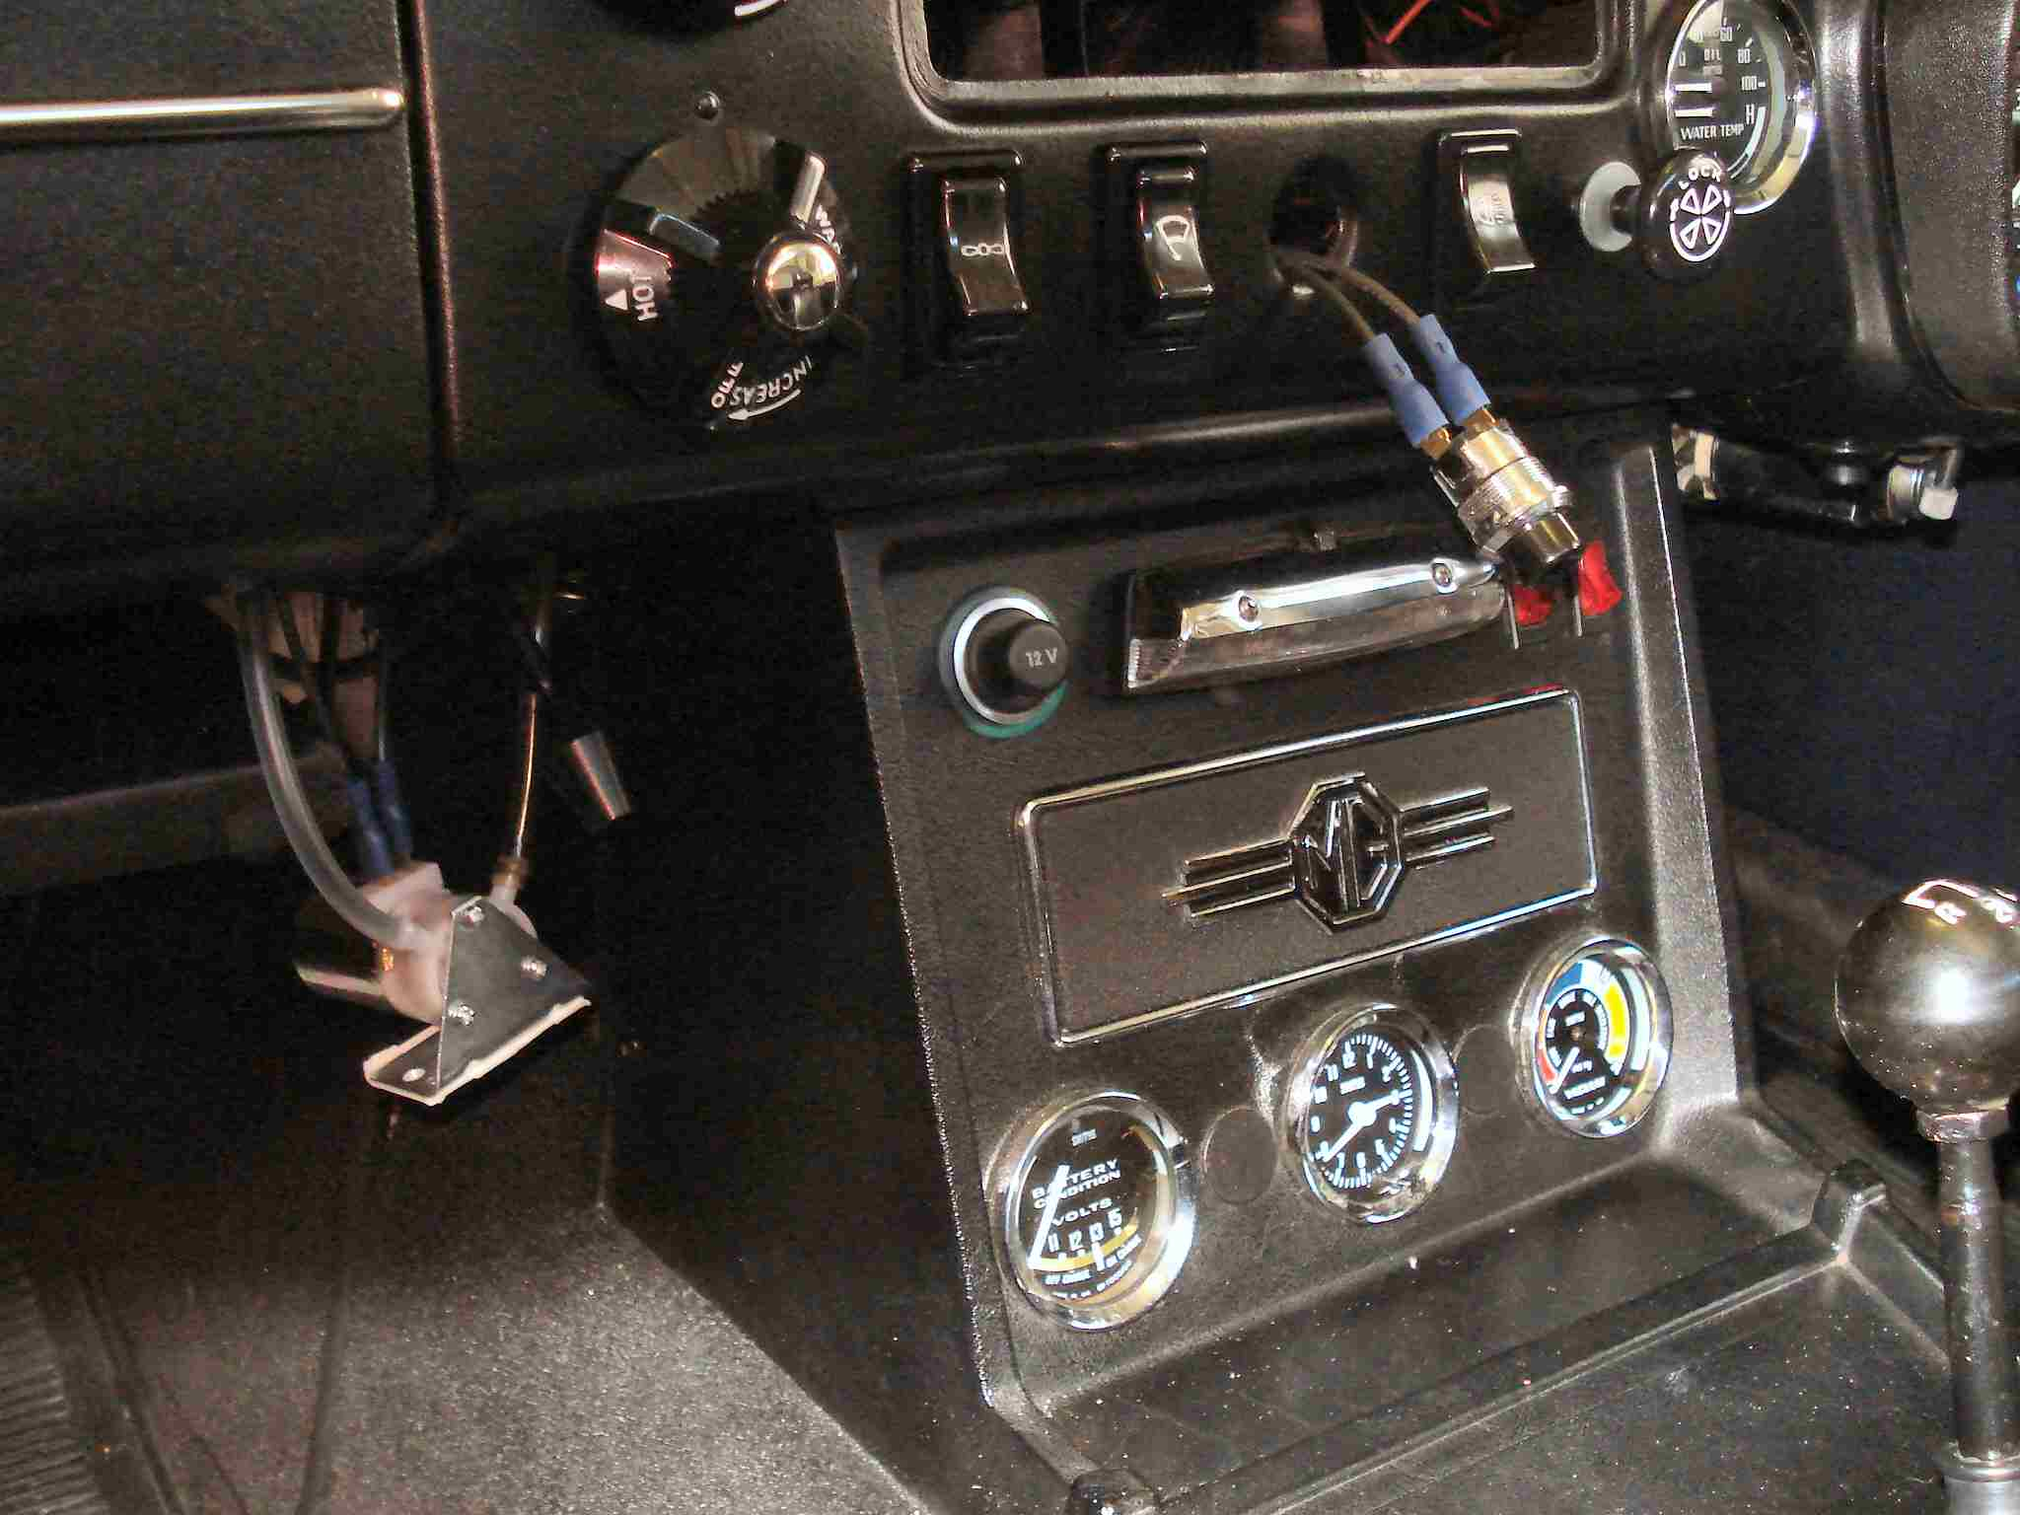

New assembly before final installation, showing pump on lower left
and push button switch on upper right.

One final word of warning. When you come to test the system for the first time don’t do as I did and lean in from the outside of the car and press the switch, with the hood down. The jets are much more powerful than with the old manual system and they shot water over the top of the windscreen and gave me an eyeful!

Kevin Prosser
January 2020

